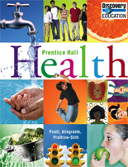
How to access my on-line Health textbook:
You now have an easier way to access your online Health textbook from school or home. You will be using the following methods and logging in with your school network username and password (the same one that allows you to access skyward). If you ever change your password on a school computer, it with sync with your textbook access. Yay! Now there is no need to remember multiple logins/passwords!
School Computer Desktop:
Once logged into a school computer, double click on the desktop icon “Pearson EasyBridge”

Home computer or laptop:

- Class Website - www.health9.weebly.com …click on the Health Textbook link down at the bottom right of your screen under Health Class
Or
- Go directly to the URL - https://goo.gl/ZtoRxl
Or
- Holt Public Schools Webpage – www.hpsk12.net
- Parent/Student Resources
Common Educational Resources : Secondary (Grades 7-12)
Literacy: Pearson EasyBridge

LOGGING IN:
- Type your school computer network user name with @hpsk12.net added to the end of it.
- Type in your school computer network password.
- Click on Health 2010 National Online Student Addition
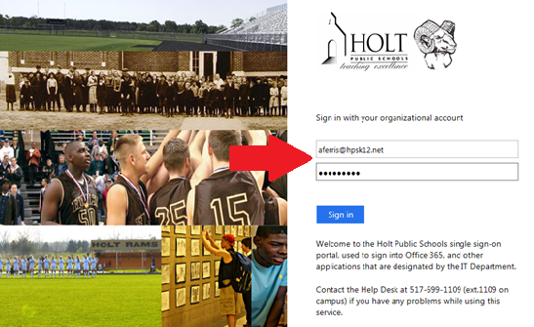

Notes:
- This process has been created to make it easier for you (you do not need to carry a book back and forth) and to be more cost saving.
- If you do not have internet access available to you outside of school, I have books that may be checked out for 1 – 2 days.
- A few places and times that you will be able to use a textbook or use the school computers:
  - The high school media center is open from: 7:00 a.m. – 7:30 a.m. M, T, Th and F, during A and B lunch with a pass from me, or after school from 2:30 p.m. – 4:00 p.m.
  - The Capital Area District Library: hours may vary depending on the location, call ahead.
  - I have office hours from 7:00 a.m. – 7:30 a.m. M, T, Th and F or 10:00 – 10:30 a.m. Wed or after school with advanced notice.
  - If you are unable to access the internet outside of school you will need to use your time management skills to plan in advance when you will need to use the schools resources.
- Students will be held responsible for the use and conditions of the classroom text and the checked out textbooks. The cost to replace a lost or severely damaged text book is $70!
- Please use these with care.
- If you have any difficulties with the on-line login etc. please contact your instructor immediately.

  - aferris@hpsk12.net
  - egraf@hpsk12.net
  - jboike@hpsk12.net

